How to view your event attendance in StudentHub
Please follow the instructions below. This will show you the events you attended from June 2017.
If you believe you attended events prior to this, please request a record by emailing graduateschool@uq.edu.au

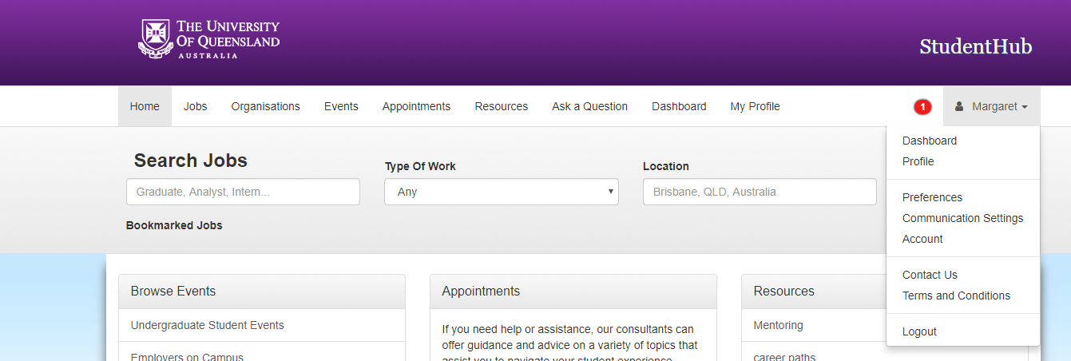

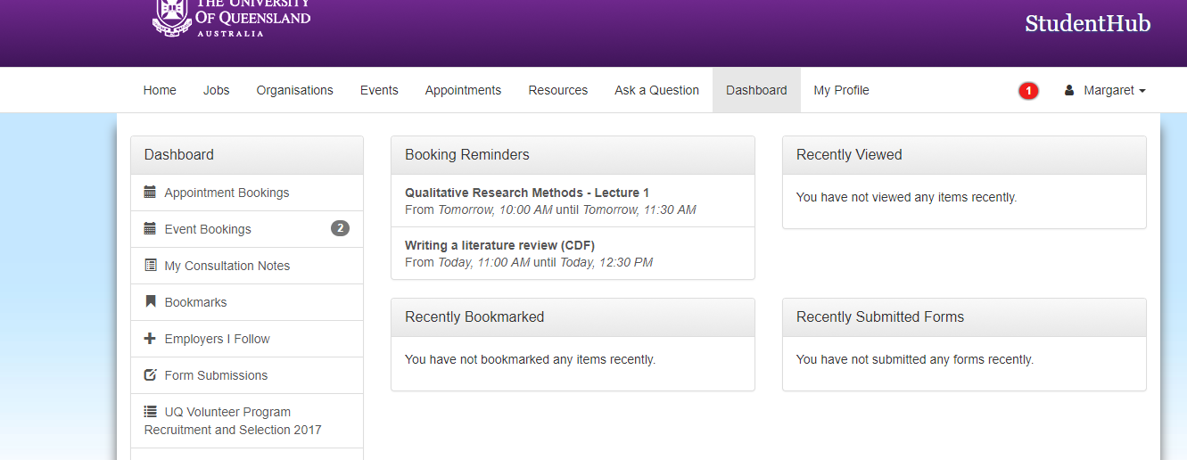

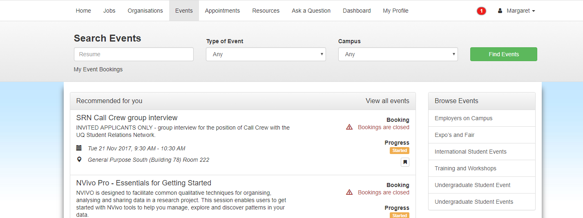

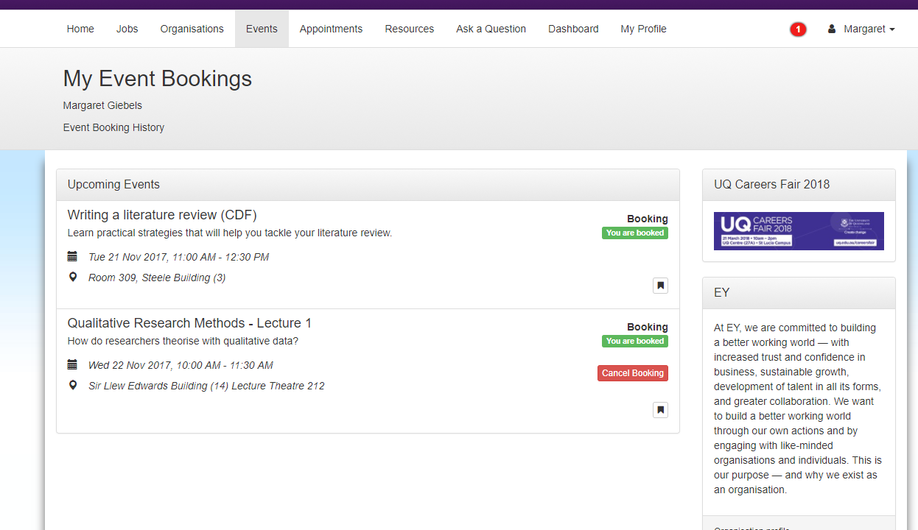

Results return:

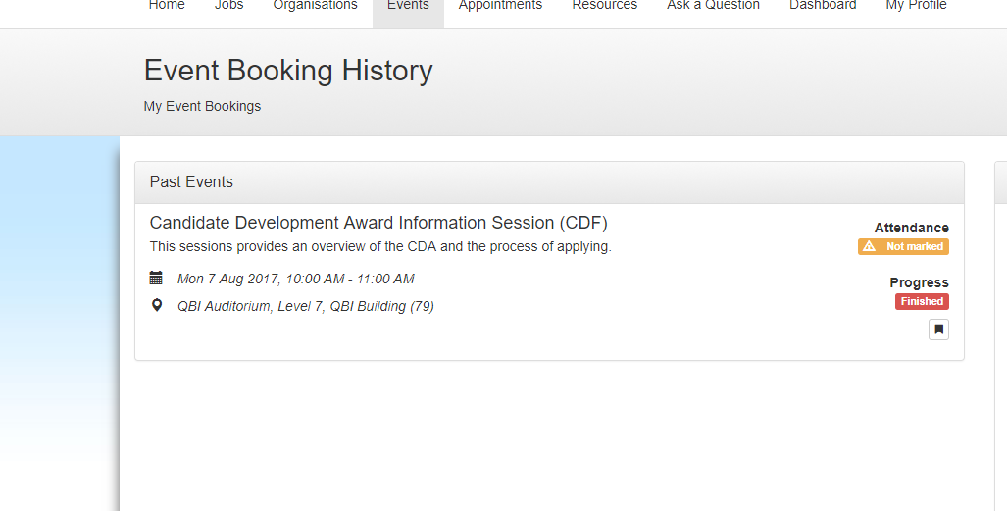

9 March 2018

